Phase 6: User Interface Development

1. Introduction
Phase 6 focuses on building a user-friendly interface in Salesforce using Lightning Experience tools. The objective is to provide business users and external partners with an intuitive interface for interacting with Orders, Products, and Inventory, while integrating Apex and automation seamlessly.
Objectives:
- Create Lightning Pages, Apps, and Tabs for better navigation.
- Develop Lightning Web Components (LWC) to display and interact with Salesforce data.
- Integrate Apex with LWC to perform dynamic operations.
- Optimize page layouts and compact layouts for user convenience.
- Implement navigation, events, and wire services to fetch and display real-time data.

2. Lightning App Builder
Steps Completed:
- Navigated to Setup → App Builder → Lightning App Builder.
- Created a new App Page for Partner Orders:
  - Name: Partner Order Dashboard
  - Template: One Region or Two Regions (for flexibility)
- Dragged standard components: Record Detail, Related Lists, Report Chart.
- Configured Visibility Rules to show components only to specific profiles/roles.
Lightning App Builder → App Page layout → Components visible.
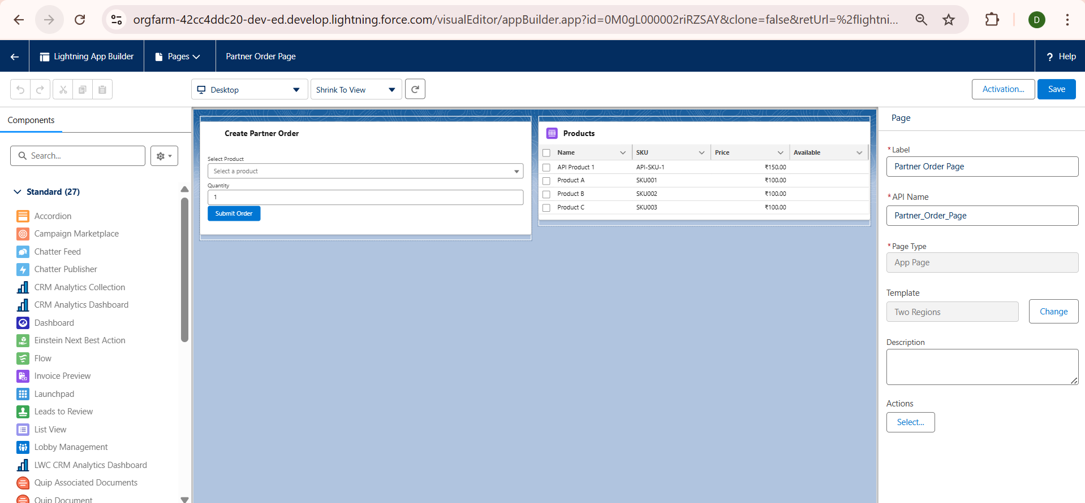

3. Record Pages
Steps Completed:
- Customized Order_Record_Page_Custom for Partner_Order__c:
  - Added Record Detail component to show order info.
  - Added Related Lists component to show Order_Line_Item__c.
  - Embedded a Custom LWC to display real-time inventory availability.
- Activated page as Org Default for the Partner_Order__c object.

4. Tabs & Navigation
Steps Completed:
- Created Custom Tabs:
  - Partner Orders Tab → Linked to Partner_Order__c object.
  - Products Tab → Linked to Product__c object.
- Ensured tabs are accessible in Lightning Apps for users and partners.
- Added tabs to Navigation Bar in Partner Order Dashboard App.
Setup → Tabs → Custom Tabs list with new tabs highlighted.
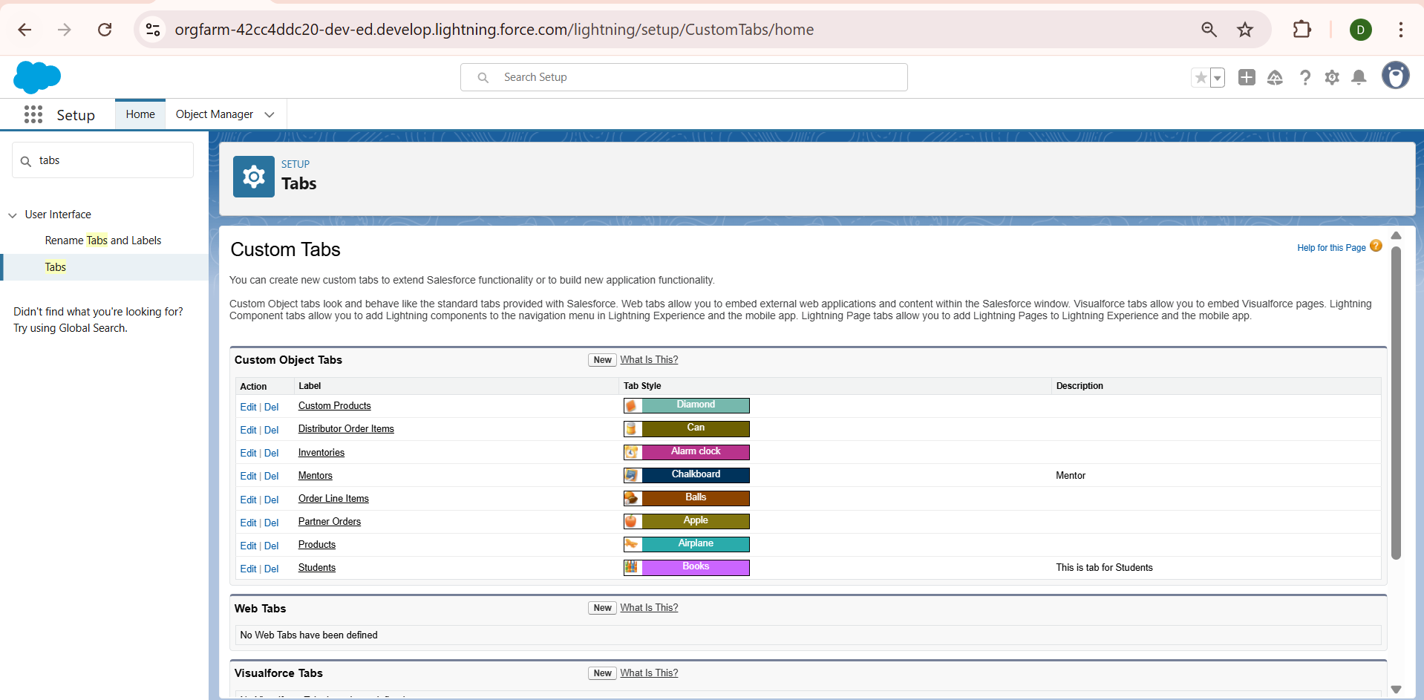

5. Lightning Web Components (LWC)
LWC Development:
- Purpose: Display products, available inventory, and create orders dynamically.
- Integration with Apex:
  - Imperative Apex Calls: Fetch inventory for selected products.
  - Wire Service: Auto-refresh product list when data changes.
  - Events: Send order creation events from child components to parent components.
Example LWC Structure:
partnerOrder
├── partnerOrder.html → Layout of products & inventory
├── partnerOrder.js → Apex calls and events handling
├── partnerOrder.css → Custom styling
└── partnerOrder.js-meta.xml → Metadata for component
Key Features Implemented:
- Real-time product search and selection.
- Quantity input with validation against available inventory.
- Create Order button integrated with PartnerOrderService Apex class.
- Success/Error toast messages after order creation.
VS Code → Explorer → Highlight partnerOrder LWC folder.
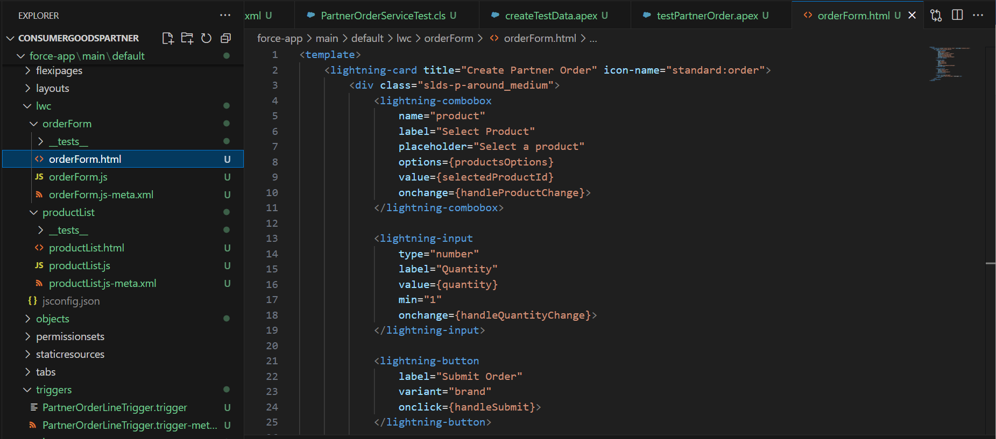
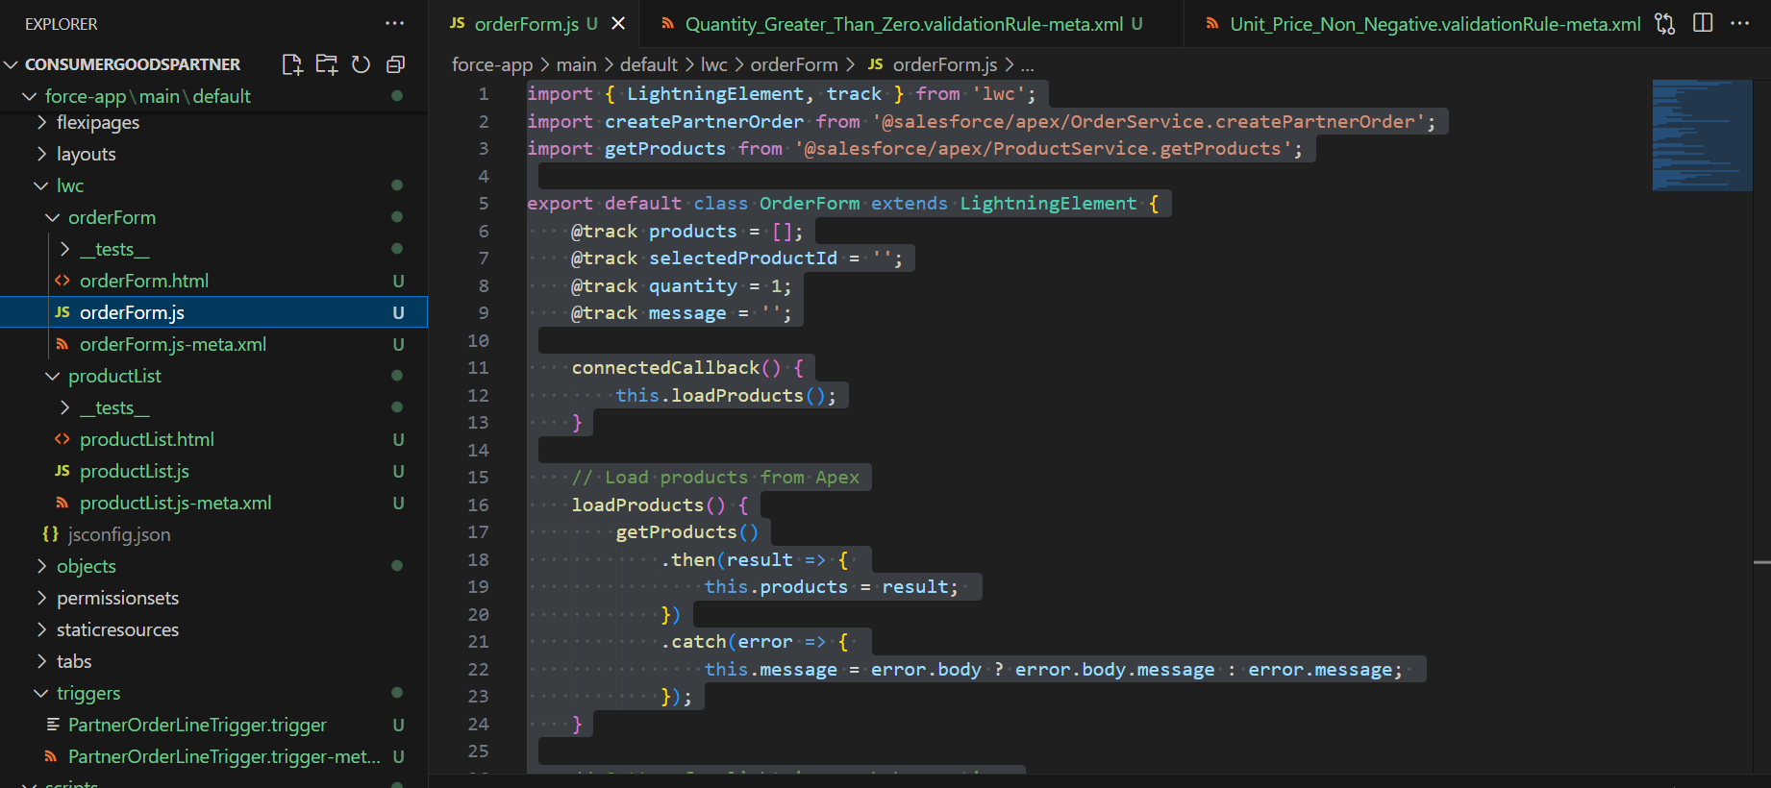

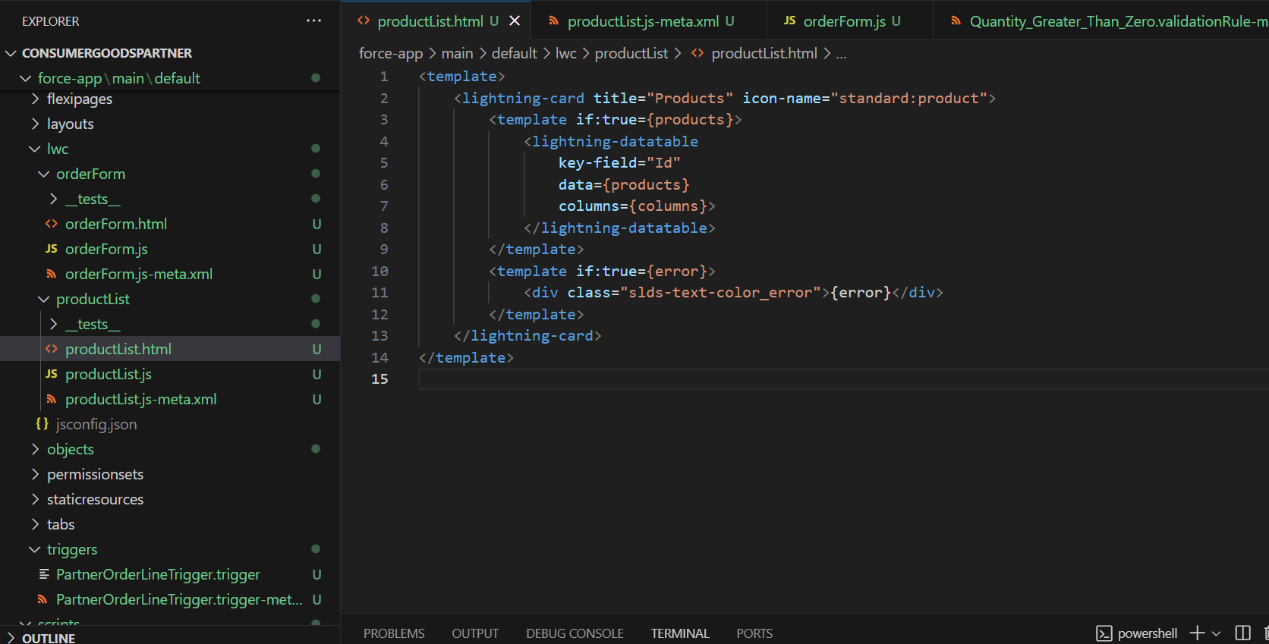

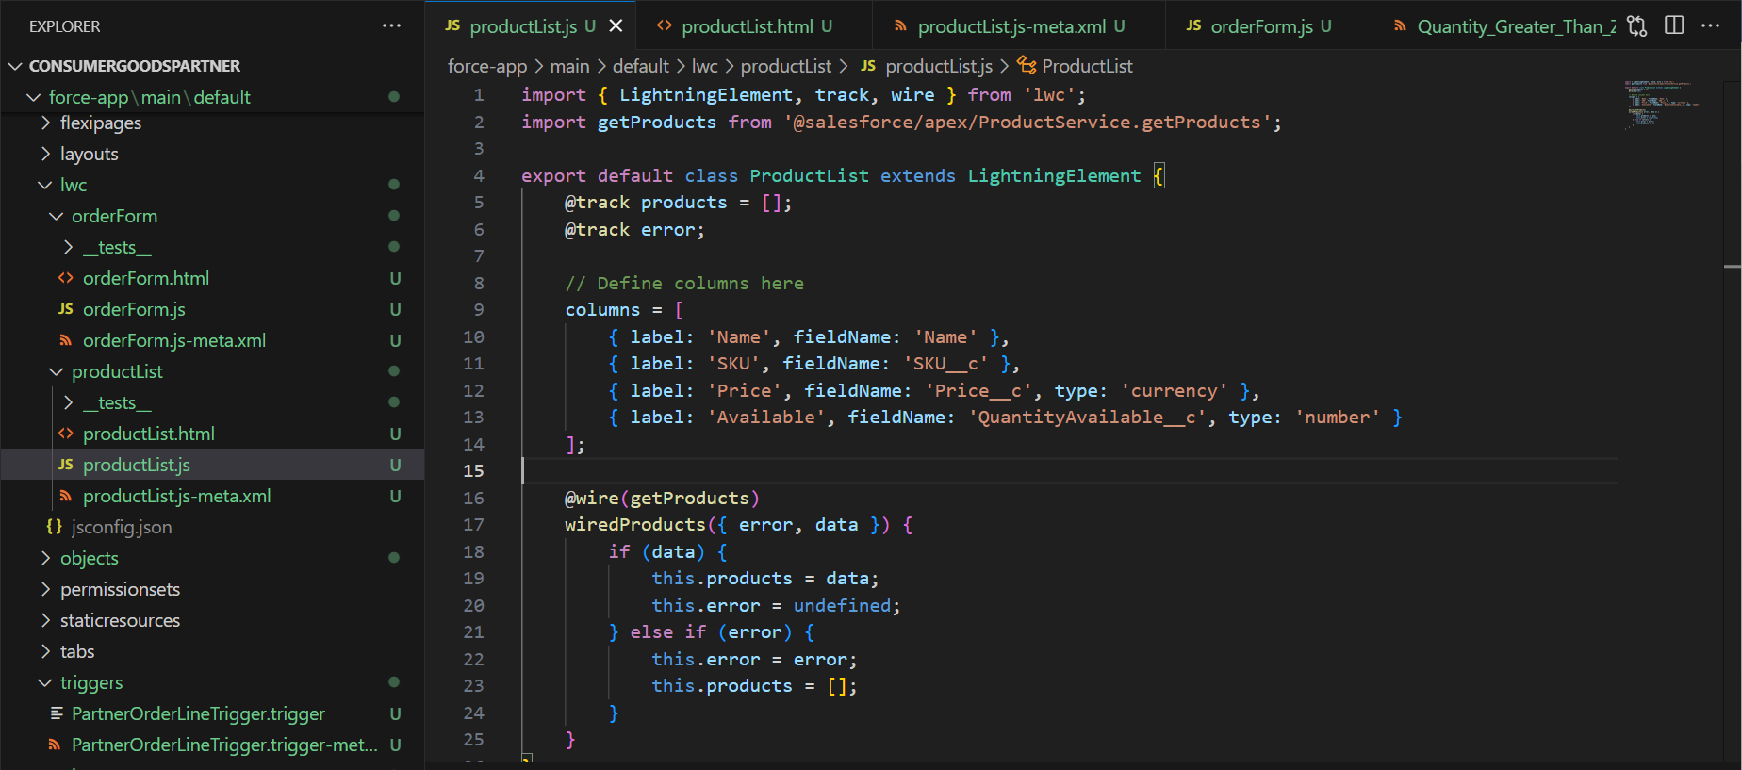

6. Home Page Layouts & Utility Bar
Steps Completed:
- Edited Lightning Home Page to add Partner Dashboard:
  - Components: Recent Orders, Inventory Alerts, Quick Links.
- Configured Utility Bar:
  - Added Quick Create Orders, Search Products, Notifications.
  - Users can access these tools from anywhere in the app.

7. Apex Integration with LWC
- Imperative Apex Example: Fetch Inventory for selected products:
import getInventory from '@salesforce/apex/InventoryController.getInventory';

handleFetchInventory(productId) {
getInventory({ productId: productId })
.then(result => { this.inventory = result; })
.catch(error => { this.error = error; });
}
- Wire Service Example: Auto-fetch products list:
import { LightningElement, wire } from 'lwc';
import getProducts from '@salesforce/apex/ProductService.getProducts';

export default class ProductList extends LightningElement {
@wire(getProducts) products;
}
Screenshot Suggestion: VS Code → LWC JS files → Apex method calls highlighted.

8. Navigation Service
- Implemented NavigationMixin to route users to record pages or apps dynamically.
- Example: Navigate to newly created Partner Order after creation:
import { NavigationMixin } from 'lightning/navigation';

this[NavigationMixin.Navigate]({
type: 'standard__recordPage',
attributes: {
recordId: this.orderId,
objectApiName: 'Partner_Order__c',
actionName: 'view'
}
});

9. Outcome of Phase 6
- Fully customized Lightning pages for orders, products, and dashboards.
- Developed LWC components integrated with Apex for real-time functionality.
- Created custom tabs and home page layouts for smooth navigation.
- Enabled dynamic navigation and event handling in LWCs.
- Users and partners can now interact with data seamlessly, with instant updates reflected in Salesforce.

